Dear Families,
Welcome to Kindergarten! We are very excited to get to know you and your family this year! We know you’ve had a busy summer, but we’re ready to get back into the swing of things. We have a lot to learn this year!
Here are some supplies that would be helpful to start your year with:
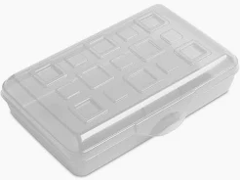
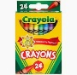
1 - Plastic pencil box (8x5x2)
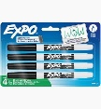
4 - Boxes 24 ct. crayons (Crayola preferred)
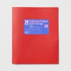
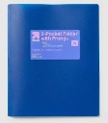
8 -Low odor thin dry erase markers (black ink)
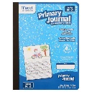
2 - Plastic 2-pocket folders with clips (blue, red)
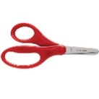
1 - Primary writing journal (has large space for drawing and writing lines)
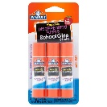
1 - Pair of blunt tip scissors
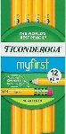
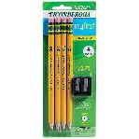
12 - Glue sticks
- Pack of My First Ticonderoga pre- sharpened pencils

We are so excited to work with you all this year!
Thanks so much!
The Kindergarten Team

Dear Families,
Welcome to First Grade! We are very excited to get to know you and your family this year! We know you’ve had a busy summer, but we’re ready to get back into the swing of things. We have a lot to learn this year!
Here are some supplies that would be helpful to start your year with:
12- BLACK dry-erase markers
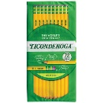
3- boxes of 24 count crayons
12- regular pencils (pre-sharpened, if possible)
3- plastic 3-pronged pocket folders (green, blue, red)
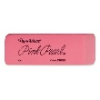
12- small glue sticks (NOT scented)
1- pink pearl eraser
1-kid size scissors
1-plastic pencil box (no pouches, please)

We are so excited to work with you all this year!
Thanks so much!
The First Grade Team

Dear Families,
Welcome to 2nd grade! We are very excited to get to know you and your family this year! We know you’ve had a busy summer, but we’re ready to get back into the swing of things. We have a lot to learn this year!
Here are some supplies that would be helpful to start your year with. Please do NOT label supplies. They will be put in storage for the class throughout the year. Thank you!
5- packs of dry erase markers
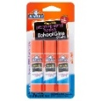
2 - plastic or poly-vinyl folders
10- glue sticks
1- pair of scissors
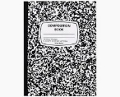
1- 24 pack of pencils (pre-sharpened if possible!)
3-composition style notebooks
1- pencil box (please no zippered pouches or locking boxes)
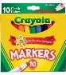
1- pack crayons or colored pencils (your choice)
1- pack of markers

We are so excited to work with you all this year!
Thanks so much!
The Second Grade Team

Dear Families,
Welcome to 3rd grade! We are very excited to get to know you and your family this year! We know you’ve had a busy summer, but we’re ready to get back into the swing of things. We have a lot to learn this year!
Here are some supplies that would be helpful to start your year with:
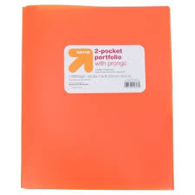
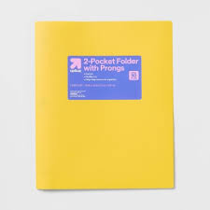
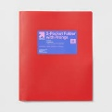
1 - red 2-pocket plastic folder
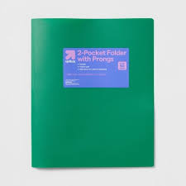
1 - blue 2-pocket plastic folder
1 - yellow 2-pocket plastic folder
1 - green 2-pocket plastic folder
1 - any color 2-pocket plastic folder
4 - 12 packs of pre-sharpened pencils
2 - 4 pack of black, thin dry erase markers
2 - 24 packs of crayons (Crayola if possible)
2 - small glue sticks
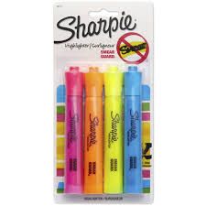
1 - pencil box (no lock)
1 – 4 pack of multi-colored highlighters
We are so excited to work with you all this year!
Thanks so much!
The Third Grade Team

Dear Families,
Welcome to 4th grade! We are very excited to get to know you and your family this year! We know you’ve had a busy summer, but we’re ready to get back into the swing of things. We have a lot to learn this year!
Here are some supplies that would be helpful to start your year with:
5 - 3-pronged pocket plastic folders
2- marble composition books (wide rule 9.75x7.5 100ct)
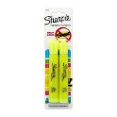
2 - large washable glue sticks
2 - yellow chisel tip highlighters
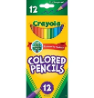
2- packs of sharpened #2 yellow wood case pencils
1 - 12ct pack of full-length colored pencils (pre-sharpened)
2 – 4-packs of black low odor dry erase markers (fine black only please)
1 pair of student scissors
We are so excited to work with you all this year!
Thanks so much!
The Fourth Grade Team

Dear Families,
Welcome to 5th grade! We are very excited to get to know you and your family this year! We know you’ve had a busy summer, but we’re ready to get back into the swing of things. We have a lot to learn this year!
Here are some supplies that would be helpful to start your year with:
3 - 3-pronged pocket plastic folders
2 - marble composition books (100 sheet wide ruled if possible)
1 – pencil box
4 - assorted color highlighters
2- packs of sharpened #2 yellow wood case pencils
1 - 12ct pack of full-length colored pencils (pre-sharpened)
1- pack of washable markers
8 – dry erase markers (any color)
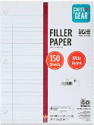
1 pair of student scissors
1 pack of loose-leaf paper (wide rule if possible)
We are so excited to work with you all this year!
Thanks so much!
The Fifth Grade Team

Special Education Supply List 2026-2027

Welcome to the 2026-2027 school year, we are so excited to have your student in our classes. We are going to have a great year.
Here are some supplies that would be helpful for your child to have at the start of the school year.
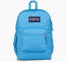
Classroom Items
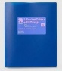
- backpack
- plastic folder
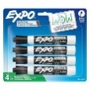
1 plastic pencil box (not a pouch)
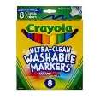
1 4 count black expo markers (thick)
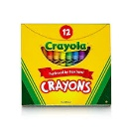
1 8 count markers
1 12 count crayons
1 12 count package glue sticks

Personal Items
Change of clothes (shirt, shorts or pants, and underwear)
Diapers/pullups and wipes (if necessary)

Daily Snack
Healthy Snack (every day)
Water Only (every day)

If you have any questions, please don’t hesitate to contact us.
Mrs. Natysin (natysisl@pwcs.edu)
Mrs. Ashworth (ashwora@pwcs.edu)
Mrs. Wise (vangorms@pwcs.edu)

